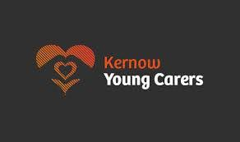

When a young person looks after someone in their family who has a serious physical or mental illness, disability or substance misuse problem, he or she may need a little extra support to help him or her get the most out of school. Our Young Carers Policy says how we will help any pupil who helps to look after someone at home.
Kernow Young Carers Service is an Action for Children service that is committed to working with children and supporting young carers. They can offer fun activities, days out, one to one help, residential breaks away, the opportunity to meet new people, support for the whole family and access to grants.
For more information, please visit the Kernow Young Carers Service website, or speak with our Parent Support Adviser Mrs Sarah Chown.

You can contact Sarah Chown on 07512 267 449

www.kernowyoungcarers.org



