St Stephen Churchtown Academy E-Safety Policy

Background / Rationale

New technologies have become integral to the lives of children and young people in today’s society, both within schools and in their lives outside school.
The internet and other digital and information technologies are powerful tools, which open up new opportunities for everyone. Electronic communication helps teachers and pupils learn from each other. These technologies can stimulate discussion, promote creativity and increase awareness of context to promote effective learning. Children and young people should have an entitlement to safe internet access at all times.
The requirement to ensure that children and young people are able to use the internet and related communications technologies appropriately and safely is addressed as part of the wider duty of care to which all who work in schools are bound. A school e-safety policy should help to ensure safe and appropriate use. The development and implementation of such a strategy should involve all the stakeholders in a child’s education from the head teacher and Hub Council to the senior leaders and classroom teachers, support staff, parents, members of the community and the students / pupils themselves.
Possible dangers
The use of these exciting and innovative tools in school and at home has been shown to raise educational standards and promote pupil / student achievement.
However, the use of these new technologies can put young people at risk within and outside the school. Some of the dangers they may face include:
• Access to illegal, harmful or inappropriate images or other content
• Unauthorised access to / loss of / sharing of personal information
• The risk of being subject to grooming by those with whom they make contact on the internet.
• The sharing / distribution of personal images without an individual’s consent or knowledge
• Inappropriate communication / contact with others, including strangers
• Cyber-bullying
• Access to unsuitable video / internet games
• An inability to evaluate the quality, accuracy and relevance of information on the internet
• Plagiarism and copyright infringement
• Illegal downloading of music or video files
• The potential for excessive use which may impact on the social and emotional development and learning of the young person.
Many of these risks reflect situations in the off-line world and it is essential that this e-safety policy is used in conjunction with other school policies (eg behaviour, anti-bullying and child protection policies).

Schedule for Development / Monitoring / Review
4
5

This e-safety policy was approved by the Governing Body / Governors Sub Committee on:
The implementation of this e-safety policy will be monitored by the: E-Safety Coordinator and Group
Monitoring will take place at regular intervals:
The Governing Body / Governors Sub Committee will receive a report on the implementation of the e-safety policy generated by the monitoring group (which will include anonymous details of e-safety incidents) at regular intervals:
The E-Safety Policy will be reviewed annually, or more regularly in the light of any significant new developments in the use of the technologies, new threats to e-safety or incidents that have taken place. The next anticipated review date will be:
Should serious e-safety incidents take place, appropriate external persons / agencies should be informed:

Scope of the Policy

This policy applies to all members of the school community (including staff, students / pupils, volunteers, parents / carers, visitors, community users) who have access to and are users of school ICT systems, both in and out of school.
The Education and Inspections Act 2006 empowers Head teachers, to such extent as is reasonable, to regulate the behaviour of students / pupils when they are off the school site and empowers members of staff to impose disciplinary penalties for inappropriate behaviour. This is pertinent to incidents of cyber-bullying, or other e-safety incidents covered by this policy, which may take place out of school, but is linked to membership of the school.
The school will deal with such incidents within this policy and associated behaviour and anti-bullying policies and will, where known, inform parents / carers of incidents of inappropriate e-safety behaviour that take place out of school.
Roles and Responsibilities
7

The following section outlines the roles and responsibilities for e-safety of individuals and groups within the school:
Hub Council:
Councilloras are responsible for the approval of the E-Safety Policy and for reviewing the effectiveness of the policy. A member of the Hub Council has taken on the role of E-Safety The role will include:
• regular meetings with the E-Safety Co-ordinator / Officer
• regular monitoring of e-safety incident logs
• regular monitoring of filtering / change control logs
• reporting to Hub Council / meeting
Headteacher and Senior Leaders:
• The Headteacher is responsible for ensuring the safety (including e-safety) of members of the school community, though the day to day responsibility for e-safety will be delegated to the E-Safety Co-ordinator.
• The Headteacher / Senior Leaders are responsible for ensuring that the E-Safety Coordinator / Officer and other relevant staff receive suitable CPD to enable them to carry out their e-safety roles and to train other colleagues, as relevant
• The Headteacher / Senior Leaders will ensure that there is a system in place to allow for monitoring and support of those in school who carry out the internal e-safety monitoring role.
• The Senior Leadership Team will receive regular monitoring reports from the E-Safety Co-ordinator / Officer.
• The Headteacher and another member of the Senior Leadership Team should be aware of the procedures to be followed in the event of a serious e-safety allegation being made against a member of staff.

E-Safety Coordinator / Officer:
8

• takes day to day responsibility for e-safety issues and has a leading role in establishing and reviewing the school e-safety policies / documents
• ensures that all staff are aware of the procedures that need to be followed in the event of an e-safety incident taking place.
• provides training and advice for staff
• liaises with the Academy Trust
• liaises with school ICT technical staff
• receives reports of e-safety incidents and creates a log of incidents to inform future e-safety developments,
• meets regularly with E-Safety Group to discuss current issues, review incident logs and filtering / change control logs
• attends relevant meeting / Safety Group
• reports regularly to Senior Leadership Team

Network Manager / Technical staff:
The ICT Technician / ICT Co-ordinator is responsible for ensuring:
• that the school’s ICT infrastructure is secure and is not open to misuse or malicious attack
• that the school meets the e-safety technical requirements outlined in the SWGfL Security Policy and Acceptable Usage Policy and any relevant Local Authority E-Safety Policy and guidance
• that users may only access the school’s networks through a properly enforced password protection policy, in which passwords are regularly changed
• that he / she keeps up to date with e-safety technical information in order to effectively carry out their e-safety role and to inform and update others as relevant
• that the use of the network is regularly monitored in order that any misuse / attempted misuse can be reported to the E-Safety Co-ordinator for investigation.
9
• that monitoring software / systems are implemented and updated as agreed in school policies
Teaching and Support Staff
are responsible for ensuring that:
• they have an up to date awareness of e-safety matters and of the current school e-safety policy and practices
• they have read, understood and signed the school Staff Acceptable Use Policy / Agreement (AUP)
• they report any suspected misuse or problem to the E-Safety Co-ordinator for investigation.
• digital communications with pupils (email / Virtual Learning Environment (VLE) / voice) should be on a professional level.
• e-safety issues are embedded in all aspects of the curriculum and other school activities
• pupils understand and follow the school e-safety and acceptable use policy
• pupils have a good understanding of research skills and the need to avoid plagiarism and uphold copyright regulations
• they monitor ICT activity in lessons, extra curricular and extended school activities
• they are aware of e-safety issues related to the use of mobile phones, cameras and hand held devices and that they monitor their use and implement current school policies with regard to these devices
• in lessons where internet use is pre-planned pupils should be guided to sites checked as suitable for their use and that processes are in place for dealing with any unsuitable material that is found in internet searches.
Designated person for child protection / Child Protection Officer
should be trained in e-safety issues and be aware of the potential for serious child protection issues to arise from:
• sharing of personal data
• access to illegal / inappropriate materials
• inappropriate on-line contact with adults / strangers
• potential or actual incidents of grooming
• cyber-bullying

Pupils:
• are responsible for using the school ICT systems in accordance with the Student / Pupil Acceptable Use Policy, which they will be expected to sign before being given access to school systems.
• have a good understanding of research skills and the need to avoid plagiarism and uphold copyright regulations
• need to understand the importance of reporting abuse, misuse or access to inappropriate materials and know how to do so
• will be expected to know and understand school policies on the use of mobile phones, digital cameras and hand held devices. They should also know and understand school policies on the taking / use of images and on cyber-bullying.
• should understand the importance of adopting good e-safety practice when using digital technologies out of school and realise that the school’s E-Safety Policy covers their actions out of school, if related to their membership of the school
Parents / Carers
Parents / Carers play a crucial role in ensuring that their children understand the need to use the internet / mobile devices in an appropriate way. Research shows that many parents and carers do not fully understand the issues and are less experienced in the use of ICT than their children. The school will therefore take every opportunity to help parents understand these issues through parents’ evenings, newsletters, letters, website / VLE and information about national / local e-safety campaigns / literature. Parents and carers will be responsible for:
• endorsing (by signature) the Student / Pupil Acceptable Use Policy
• accessing the school website / VLE / on-line student / pupil records in accordance with the relevant school Acceptable Use Policy.

Policy Statements
11

Education – students / pupils
Whilst regulation and technical solutions are very important, their use must be balanced by educating pupils to take a responsible approach. The education of pupils in e-safety is therefore an essential part of the school’s e-safety provision. Children and young people need the help and support of the school to recognise and avoid e-safety risks and build their resilience.
E-Safety education will be provided in the following ways:
• A planned e-safety programme should be provided as part of ICT / PHSE / other lessons and should be regularly revisited – this will cover both the use of ICT and new technologies in school and outside school
• Pupils should be taught in all lessons to be critically aware of the materials / content they access on-line and be guided to validate the accuracy of information

Education – parents / carers
Many parents and carers have only a limited understanding of e-safety risks and issues, yet they play an essential role in the education of their children and in the monitoring / regulation of the children’s on-line experiences. Parents often either underestimate or do not realise how often children and young people come across potentially harmful and inappropriate material on the internet and are often unsure about what they would do about it. “There is a generational digital divide”. (Byron Report).
The school will therefore seek to provide information and awareness to parents and carers through:

• Letters, newsletters, web site
• Parents evenings

Education & Training – Staff
It is essential that all staff receive e-safety training and understand their responsibilities, as outlined in this policy. Training will be offered as follows:
• The E-Safety Coordinator will receive regular updates through attendance at training sessions and by reviewing guidance documents released by BECTA / SWGfL / LA and others.
• The E-Safety Coordinator will provide advice / guidance / training as required to individuals as required.

Training – Hub Councillors
Hub Councillors should take part in e-safety training / awareness sessions. This may be offered in a number of ways:
• Attendance at training provided by the Local Authority / National Governors Association / SWGfL or other relevant organisation.
• Participation in school training / information sessions for staff or parents

Technical – infrastructure / equipment, filtering and monitoring
The school will be responsible for ensuring that the school infrastructure / network is as safe and secure as is reasonably possible and that policies and procedures approved within this policy are implemented. It will also need to ensure that the relevant people named in the above sections will be effective in carrying out their e-safety responsibilities:
• School ICT systems will be managed in ways that ensure that the school meets the e-safety technical requirements outlined in the SWGfL Security Policy and Acceptable Usage Policy and any relevant Local Authority E-Safety Policy and guidance
• There will be regular reviews and audits of the safety and security of school ICT systems
• Servers, wireless systems and cabling must be securely located and physical access restricted
13
• All users will have clearly defined access rights to school ICT systems.
• All users will be provided with a username and password
• The school maintains and supports the managed filtering service provided by SWGfL
• Any filtering issues should be reported immediately to SWGfL.
• Requests from staff for sites to be removed from the filtered list will be considered by the Network Manager
• School ICT technical staff monitor and record the activity of users on the school ICT systems and users are made aware of this in the Acceptable Use Policy.
• Remote management tools are used by staff to control workstations and view users’ activity
• An appropriate system is in place for users to report any actual / potential e-safety incident to the Network Manager (or other relevant person).
• Appropriate security measures are in place to protect the servers, firewalls, routers, wireless systems, work stations, hand held devices etc from accidental or malicious attempts which might threaten the security of the school systems and data.
• The school infrastructure and individual workstations are protected by up to date virus software.

Curriculum
E-safety should be a focus in all areas of the curriculum and staff should reinforce e-safety messages in the use of ICT across the curriculum.

Use of digital and video images - Photographic, Video
The development of digital imaging technologies has created significant benefits to learning, allowing staff and students / pupils instant use of images that they have recorded themselves or downloaded from the internet. However, staff and students / pupils need to be aware of the risks associated with sharing images and with posting digital images on the internet. Those images may remain available on the internet forever and may cause harm or embarrassment to individuals in the short or longer term. There are many reported incidents of employers carrying out internet searches for information about potential and existing employees. The school will inform and educate users about these risks and will implement policies to reduce the likelihood of the potential for harm:
• When using digital images, staff should inform and educate students / pupils about the risks associated with the taking, use, sharing, publication and distribution of images. In particular they should recognise the risks attached to publishing their own images on the internet eg on social networking sites.
15
• Staff are allowed to take digital / video images to support educational aims, but must follow school policies concerning the sharing, distribution and publication of those images. Those images should only be taken on school equipment, the personal equipment of staff should not be used for such purposes.

Data Protection
Personal data will be recorded, processed, transferred and made available according to the Data Protection Act 1998.
Staff must ensure that they:
• At all times take care to ensure the safe keeping of personal data, minimising the risk of its loss or misuse.

Communications
A wide range of rapidly developing communications technologies has the potential to enhance learning. The following table shows how the school currently considers the benefit of using these technologies for education outweighs their risks / disadvantages.
When using communication technologies the school considers the following as good practice:
• The official school email service may be regarded as safe and secure and is monitored.
• Users must immediately report, to the nominated person – in accordance with the school policy, the receipt of any email that makes them feel uncomfortable, is offensive, threatening or bullying in nature and must not respond to any such email.
• Any digital communication between staff and students / pupils or parents / carers (email, chat, VLE etc) must be professional in tone and content.
• Pupils should be taught about email safety issues, such as the risks attached to the use of personal details. They should also be taught strategies to deal with inappropriate emails and be reminded of the need to write emails clearly and correctly and not include any unsuitable or abusive material.

Responding to incidents of misuse
It is hoped that all members of the school community will be responsible users of ICT, who understand and follow this policy. However, there may be times when infringements of the policy could take place, through careless or irresponsible or, very rarely, through deliberate misuse. Listed below are the responses that will be made to any apparent or actual incidents of misuse:
If any apparent or actual misuse appears to involve illegal activity ie.
• child sexual abuse images
• adult material which potentially breaches the Obscene Publications Act
• criminally racist material
• other criminal conduct, activity or materials
the SWGfL flow chart – below and http://www.swgfl.org.uk/safety/default.asp should be consulted and actions followed in line with the flow chart.
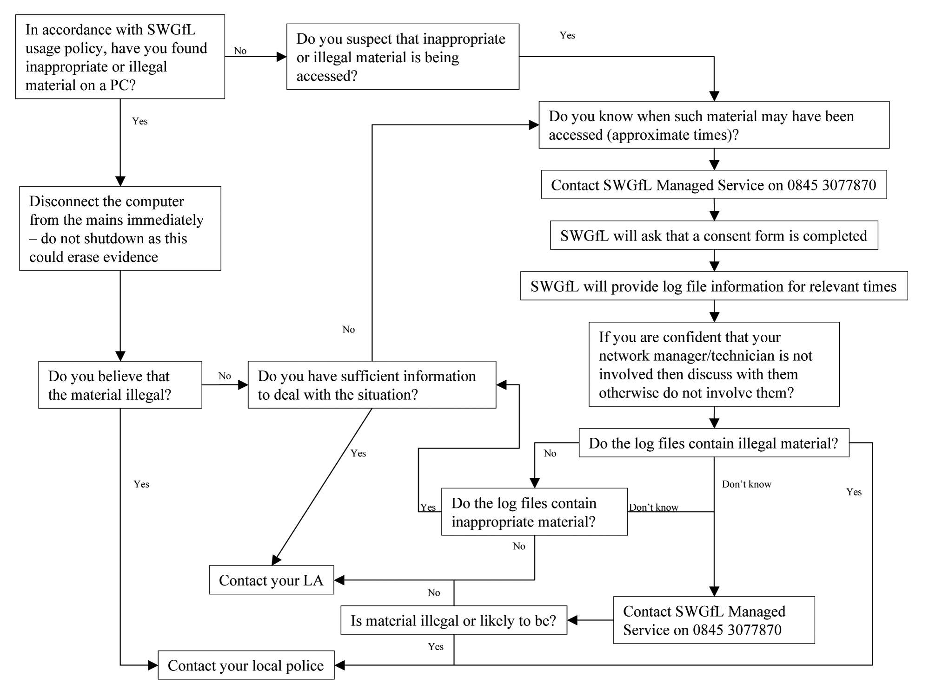

If members of staff suspect that misuse might have taken place, but that the misuse is not illegal (as above) it is essential that correct procedures are used to investigate, preserve

