Summer Term Homework (2nd ½)
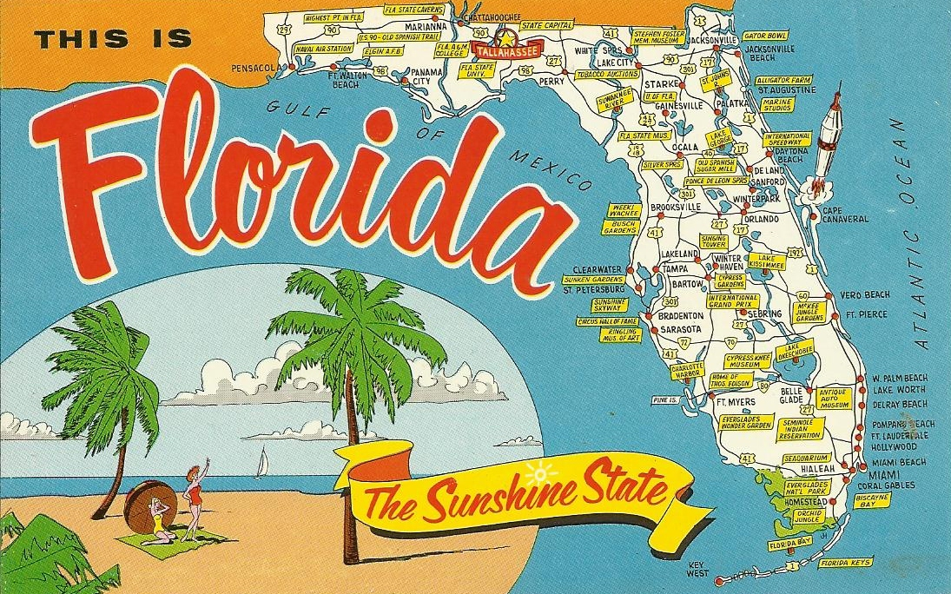
A final welcome back as we enter our last half-term and push ourselves to the finish line that is the end of the school year. Even though we are entering our final few weeks, things are as jam packed as ever! Our new topic is “The Magic Kingdom,” a geography based unit in which we will be learning all about Florida: The Sunshine State. In particular, we will be gaining an understanding of the physical and geographical features of a region in North America where we can compare and contrast it to our own in the United Kingdom. You will be required to complete one topic homework assignment that will be due just before the end of the term. You can find more information on the assignment below.
Numeracy
Repetition of number facts, including times tables and mental addition and subtraction is a skill to continuously practice. Please practice number bonds to 100 as well as your 12 times tables. We will continue learning about fractions in the next couple weeks, as well as touching on multiplication and division again and learning about area and perimeter.
Topic
This half term your topic homework will be to research ONE of the States in America. You must NOT pick the State of Florida, as that is the State we will be covering in class. You can present your findings any way you like. You can include some of the following things in your research (these are just suggestions):
- A picture of your State.
- Location of your State (where is it in the USA)
- Physical features (natural geographical features/attractions)
- Human features (man-made attractions)
- State flag/flower/animal
- Any other information you might think is interesting or important.
Again, it’s up to you as to how you wish to present your information. Please can your topic homework be returned to school by Wednesday 19th July (before hand, if completed earlier).
Each week I will continue to test spellings. Please practise the words sent home. I also ask that you read daily.
If you have any questions or queries, please do not hesitate to contact me.
As always, thank you for your continued support,
Ms Maglietta

