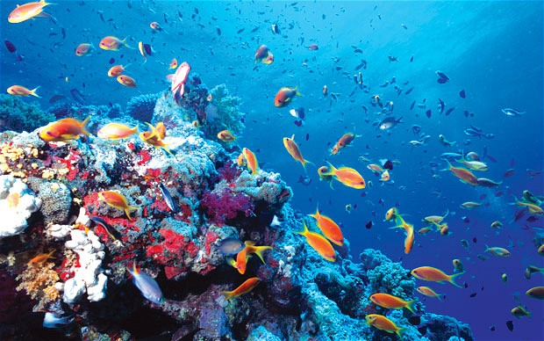
Autumn Term Homework (1st Half)
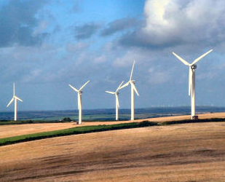
Welcome back to school! I hope you have had an enjoyable summer break. We have lots of exciting things planned for the coming half term. Our topic for the next six weeks is “Sustainability” which is a Geography based focus. We will be looking at how we can be sustainable globally as well as in our own lives and how this will impact the environment now and in the future. Students will be required to complete one topic homework assignment that will be due just before the end of the term (see below).
Numeracy
We will be focusing on Place Value this half term and knowing what each number represents (units, tens, hundreds, thousands) as this is critical in understanding how to complete the four operations (+, -, x, ÷) later in the Autumn term. I would also ask that the children start practicing their times tables to 12 and learning them so that they can recall them quickly and accurately.
Topic
This half term your topic homework will involve looking around the home and creating a personal Action Plan (attached) which focuses on sustainability in your own life. In the next few topic lessons, we will complete the same Action Plan together as a class for the school, so you should understand how to complete the grid independently for your own house.
Your topic homework is not due until Wednesday, 17th October (the last Wednesday before we break up for the half-term), so I ask that you take your time and put some thought and effort into the project. You can present your information any creative way you like, for example:
- Folder
- Poster board
- Powerpoint
- Diary/journal
- Complete attached brochure or your own brochure
However, you can also just fill in the Action Plan attached with thought and care. If you complete your work early, you can hand it in before the due date.
Each week I will test spellings. Please practice the words sent home. I also ask that you read daily.
If you have any questions or queries, please do not hesitate to contact me.
Thank you for your support,
Mrs Frost

