Helpful Websites – Safeguarding children

Please click on the pictures below to go to the website for further information
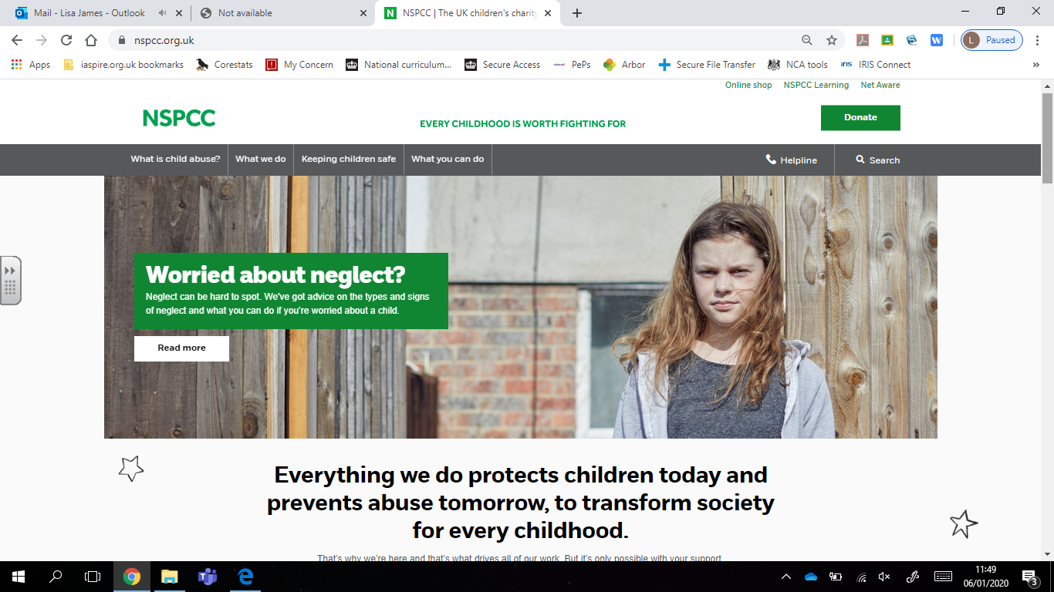
NSPCC

Young Minds
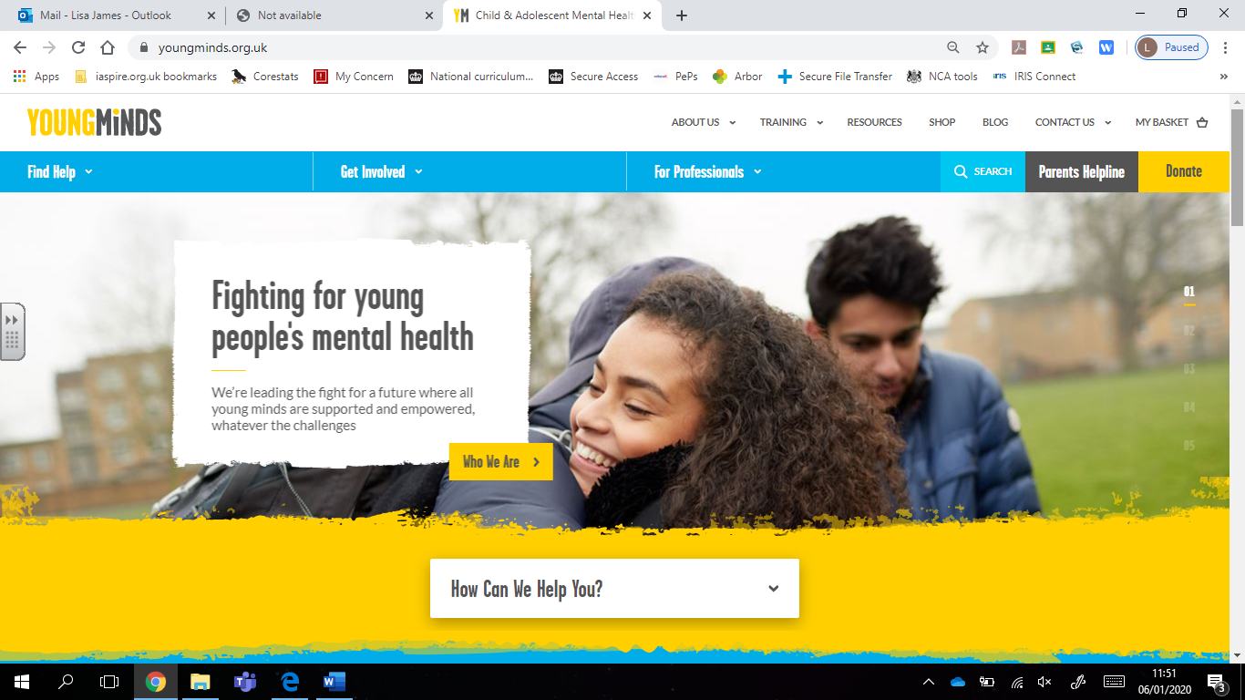

Helpful Websites – Safeguarding children

Please click on the pictures below to go to the website for further information.
Online Safety
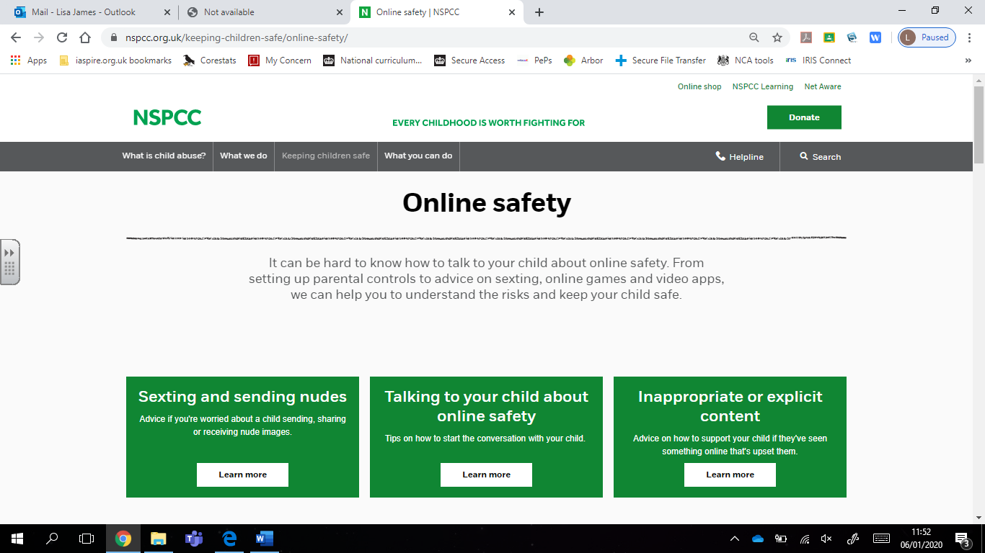

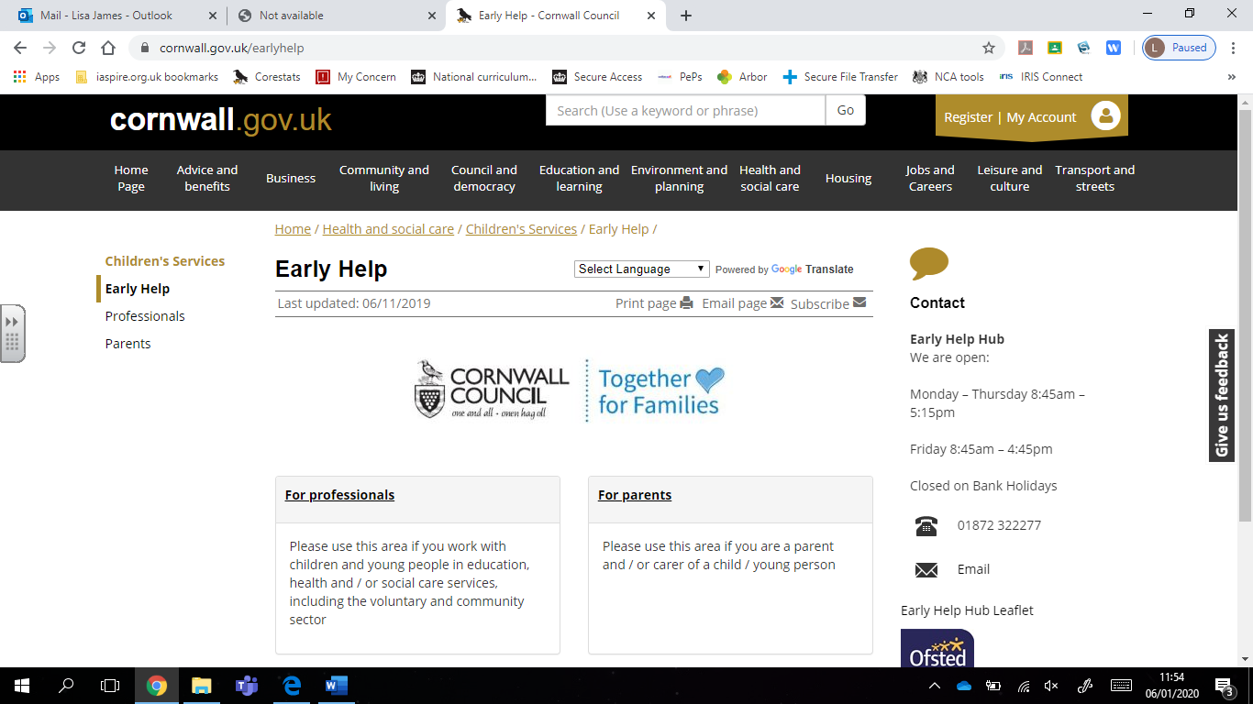
Early Help Hub

Helpful Websites – Safeguarding children

Please click on the pictures below to go to the website for further information.
MARU
